Input : Runner steps in a minute and running duration, SECONDS

Process : Calculate miles

1. STEPS = steps a minute x SECONDS

ii) FEET = STEPS x 2.5 feet

iii) MILES = FEET/5280 feet

Output : Display MILES

1. Pseudocode of the main module of how many miles runner runs

main ()

1. Start
2. Call input ()
3. Call calculateMiles ()
4. Call output
5. End

ii. Pseudocode of submodule to input the runner steps in a minute and running duration

input()

1. Start
2. Read runner steps in a minute and running duration, SECONDS
3. Return

iii. Pseudocode of submodule to calculate miles

calculateMiles()

1. Start
2. STEPS =steps a minute\*SECONDS
3. FEET = STEPS\*2.5 feet
4. MILES = FEET/5280 feet
5. Return

iv. Pseudocode of submodule to display miles

output()

1. Start

2. Display MILES

3. Return

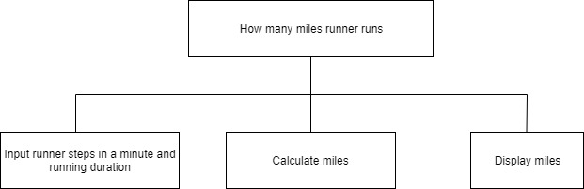

FLOWCHART

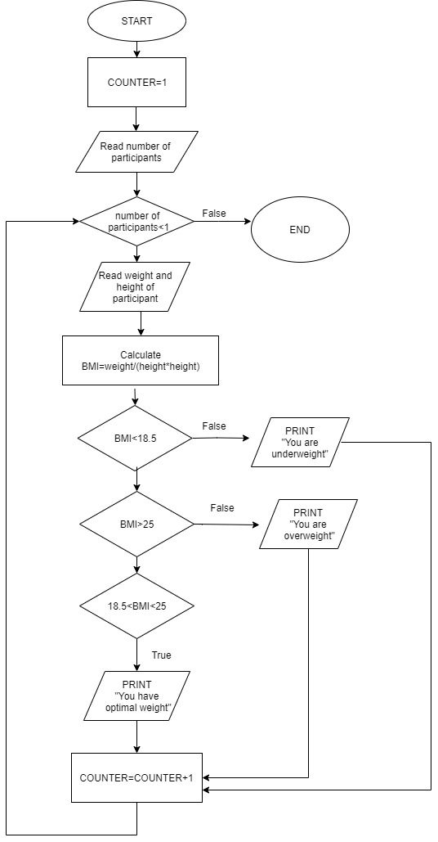

Input : Height and weight of participant

Process : i) Read height and weight

ii) Calculate BMI

BMI = weight / ( height\*height )

iii) Check BMI whether underweight, overweight or optimum weight

iv) Display suitable message

v) Repeat process

Output : Message “ You are overweight “,” You are underweight “ or “ You have optimal weight”

1. Pseudocode
2. Start
3. Set COUNTER = 1
4. Read number of participants
5. While number of participant < 1
6. Read weight and height of participant
7. Calculate BMI

BMI = weight/ ( height\*height )

1. If BMI < 18.5

Print “ You are underweight “

1. If BMI > 25

Print “ You are overweight “

1. If 18.5 < BMI < 25

Print “ You have optimal weight “

1. Add 1 to COUNTER
2. Endwhile
3. End

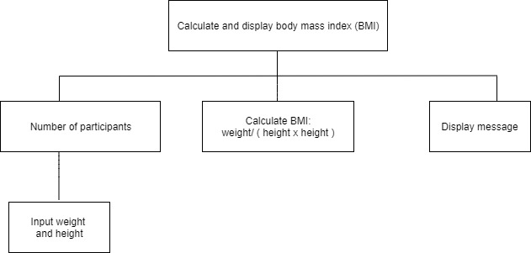

FLOWCHART

